Chapter 6

Computer Arithmetic

- Numeric format and representation of binary number in signed and unsigned notation
- Addition and Subtraction in signed and unsigned notation
- Shift and add multiplication algorithm, Booth’s algorithm. (signed and unsigned)

Numeric format and representation of binary number

Integer Representation: (Fixed-point representation)
An eight bit word can be represented the numbers from zero to 255 including
00000000 = 0
00000001 = 1
- - - - - - -
11111111 = 255
In general if an n-bit sequence of binary digits $a_{n-1}, a_{n-2} …..a_{1}, a_{0}$; is interpreted as unsigned integer A.

$A = \sum_{i=0}^{n-1}{2^{i}}a_{i}$

Sign magnitude representation
There are several alternative convention used to represent negative as well as positive integers, all of which involves treating the most significant (left most) bit in the word as sign bit. If the sign bit is 0, the number is +ve and if the sign bit is 1, the number is –ve. In n bit word the right most n-1 bit hold the magnitude of integer.
For an example,
+18 = 00010010
- 18 = 10010010 (sign magnitude)
The general case can be expressed as follows:
$A = \sum_{i=0}^{n-2}{2^{i}}a_{i}$ if $a_{n-1}=0$
$A = -\sum_{i=0}^{n-2}{2^{i}}a_{i}$ if $a_{n-1}=1$
There are several drawbacks to sign-magnitude representation. One is that addition or subtraction requires consideration of both signs of number and their relative magnitude to carry out the required operation. Another drawback is that there are two representation of zero. For an example:
+0₁₀ = 00000000
-0₁₀ = 10000000 this is inconvenient.

2’s complement representation:
Like sign magnitude representation, 2’s complement representation uses the most significant bit as sign bit making it easy to test whether the integer is negative or positive. It differs from the use of sign magnitude representation in the way that the other bits are interpreted. For negation, take the Boolean complement (1’s complement) of each bit of corresponding positive number, and then add one to the resulting bit pattern viewed as unsigned integer. Consider n bit integer A in 2’s complement representation. If A is +ve then the sign bit $a_{n-1}$ is zero. The remaining bits represent the magnitude of the number.
$A = \sum_{i=0}^{n-2}{2^{i}}a_{i}$ for $A≥0$
The number zero is identified as +ve and therefore has zero sign bit and magnitude of all 0’s. We can see that the range of +ve integer that may be represented is from 0 (all the magnitude bits are zero) through $2^{n-1}-1$ (all of the magnitude bits are 1).
Now for –ve number integer A, the sign bit $a_{n-1}$ is 1. The range of –ve integer that can be represented is from -1 to ${-2}^{n-1}$.
2’s complement, $A = -2^{n-1}a_{n-1}+\sum_{i=0}^{n-2}{2^{i}}a_{i}$
Defines the twos complement of representation of both positive and negative number.
For an example:
+18 = 00010010
1’s complement = 11101101
2’s complement = 11101110 = -18

Addition and Subtraction in signed and unsigned notation

Addition and Subtraction Using One’s Complement
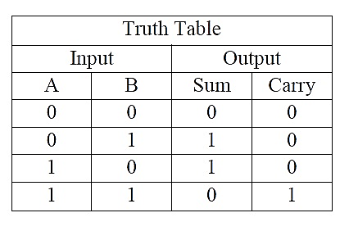
One of the main advantages of One’s Complement is in the addition and subtraction of two binary numbers. In mathematics, subtraction can be implemented in a variety of different ways as A – B, is the same as saying A + (-B) or -B + A etc. Therefore, the complication of subtracting two binary numbers can be performed by simply using addition
When the two numbers to be added are both positive, the sum A + B, they can be added together by means of the direct sum (including the number and bit sign), because when single bits are added together, “0 + 0”, “0 + 1”, or “1 + 0” results in a sum of “0” or “1”. This is because when the two bits we want to be added together are odd (“0” + “1” or “1 + 0”), the result is “1”. Likewise, when the two bits to be added together are even (“0 + 0” or “1 + 1”) the result is “0” until you get to “1 + 1” then the sum is equal to “0” plus a carry “1”.
Overflow rule: If two numbers are added and they are both positive or both negative, then overflow occurs if and only of the result have the opposite sign.
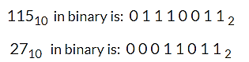
Subtraction of Two Binary Numbers
Example: An 8-bit digital system is required to subtract the following two numbers 115 and 27 from each other using one’s complement. So, in decimal this would be: 115 – 27 = 88.
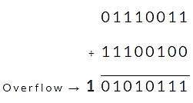
Now we need to find the complement of the second binary number, (00011011) while leaving the first number (01110011) unchanged. So, by changing all the 1’s to 0’s and 0’s to 1’s, the one’s complement of 00011011 is therefore equal to 11100100.
Adding the first number and the complement of the second number gives:
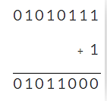
The 8-bit result from above is: 01010111 (the overflow “1” cancels out because it exceeds the memory capacity) and to convert it back from a one’s complement answer to the real answer we now have to add “1” to the one’s complement result, therefore:

Multiplication Algorithm
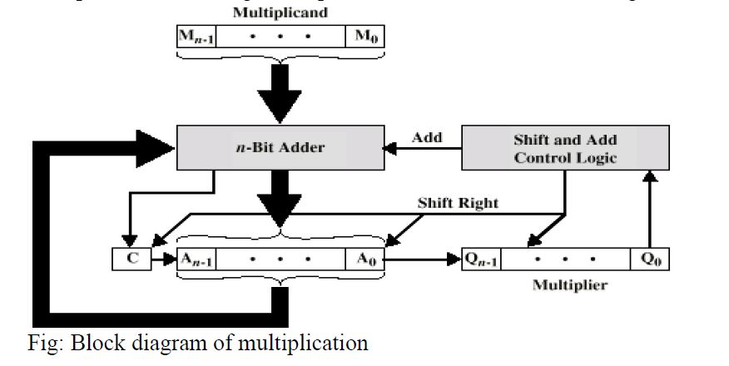
The multiplier and multiplicand bits are loaded into two registers Q and M. A third register A is initially set to zero. C is the 1-bit register which holds the carry bit resulting from addition. Now, the control logic reads the bits of the multiplier one at a time. If $Q_{0}$ is 1, the multiplicand is added to the register A and is stored back in register A with C bit used for carry. Then all the bits of CAQ are shifted to the right 1 bit so that C bit goes to $A_{n-1}$, $A_{0}$goes to $Q_{n-1}$and $Q_{0}$is lost. If $Q_{0}$ is 0, no addition is performed just do the shift. The process is repeated for each bit of the original multiplier. The resulting 2n bit product is contained in the QA register.

There are three types of operation for multiplication.
- It should be determined whether a multiplier bit is 1 or 0 so that it can designate the partial product. If the multiplier bit is 0, the partial product is zero; if the multiplier bit is 1, the multiplicand is partial product.
- It should shift partial product.
- It should add partial product.

Unsigned Binary Multiplication
1011 Multiplicand 11
X 1101 Multiplier 13
1011
0000 Partial Product
1011
+ 1011
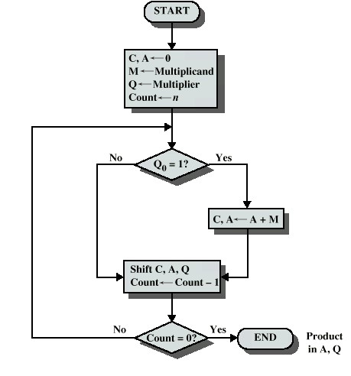
10001111 Product (143)

Fig: Flowchart of Unsigned Binary Multiplication

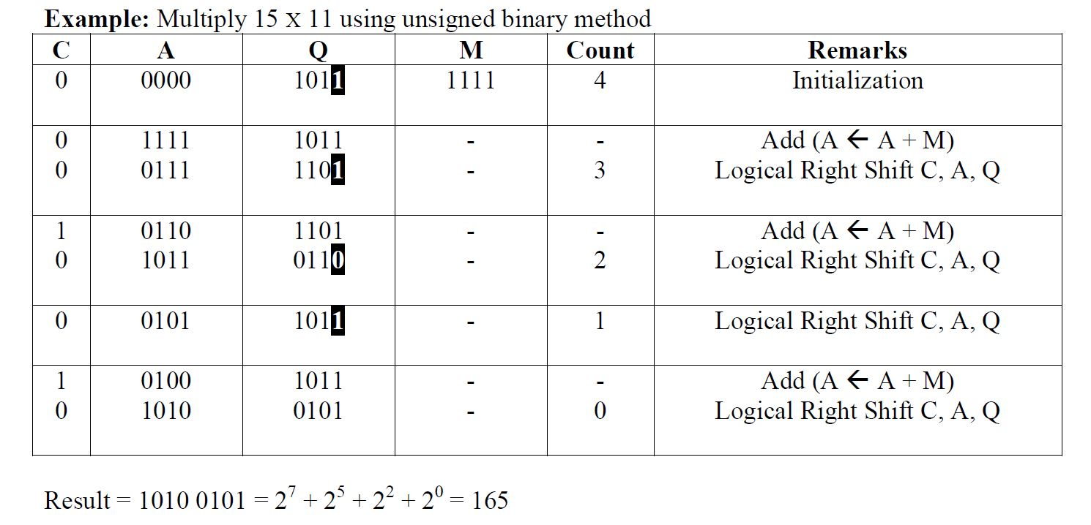

Signed Multiplication (Booth Algorithm) – 2’s Complement Multiplication
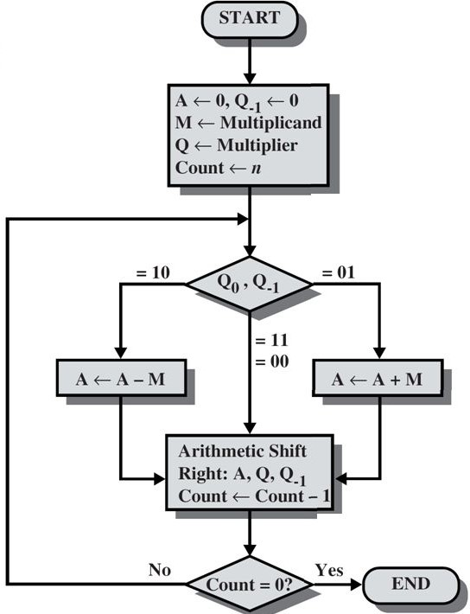
Multiplier and multiplicand are placed in Q and M register respectively. There is also one bit register placed logically to the right of the least significant bit $Q_{0}$of the Q register and designated as $Q_{-1}$. The result of multiplication will appear in A and Q resister. A and $Q_{-1}$ are initialized to zero if two bits (Q0 and $Q_{-1}$) are the same (11 or 00) then all the bits of A, Q and $Q_{-1}$ registers are shifted to the right 1 bit. If the two bits differ then the multiplicand is added to or subtracted from the A register depending on weather the two bits are 01 or 10. Following the addition or subtraction the arithmetic right shift occurs. When count reaches to zero, result resides into AQ in the form of signed integer ${[-2}^{n-1}×a_{n-1}{+2}^{n-2}×+…………….2^{1}×a_{1}+2^{0}×a_{0}$].

Multiply (-7)₁₀ and (-3)₁₀ using Booth’s algorithm.

Solution:
We have,
Multiplicand (M) = (-7)₁₀ = 1001
Multiplier (Q) = (-3)₁₀ = 1101
-M = 0111
Count (n) = 4
n | A | Q | Q₋₁ | Comments
4 | 0000 | 1101 | 0 | Initialization
4  3 | 0111  0011 | 1101  1110 | 0  1 | $A←A-M$  ashr AQQ₋₁
3  2 | 1100  1110 | 1110  0111 | 1  0 | $A←A+M$  ashr AQQ₋₁
2  1 | 0101  0010 | 0111  1011 | 0  1 | $A←A-M$  ashr AQQ₋₁
0 | 0001 | 0101 | 1 | ashr AQQ₋₁

Therefore, product (P)= 00010101 = (21)₁₀

